**­**

**Total Marks: 04**

**Marks Obtained:**

**Psychology**

**Assignment 02**

**Submitted To: Ms. Beenish Ambereen**

**Date of Submission: 23-October-2024**

|  |  |  |
| --- | --- | --- |
| **S.NO** | **Student Name** | **Reg.no** |
| **01** | **Muhammad Salman** | **2212400** |
| **02** | **Mushahid Hussain** | **2212408** |
| **03** | **Ubaid Bin Waris** | **2212416** |
| **04** | **Muhammad Rayyan Amir** | **2212406** |
| **05** | **Jehanzeb Khalid** | **2212391** |

Table of Contents

**Front Page01**

**Table of Content02**

**Addressing the Impact of Political Chaos on the Mental Health of Students in Pakistan03**

**Introduction03**

**The Context of political chaos in Pakistan03**

**Mental Health Challenges faced by Students04**

Anxiety and Depression04

Academic Performance04

Social Isolation04

**The Need for Comprehensive Solution04**

Strengthening Mental Health Services in Educational Institutions05

Promoting a Positive Educational Environment05

Community Engagement and Support06

Leveraging Technology for Mental Health Support06

Policy Advocacy and Structural Changes06

**Conclusion07**

**Reference08**

**Work Division08**

**Plagiarism Report10**

**Addressing the Impact of Political Chaos on the Mental Health of Students in Pakistan**

**Question**

Political chaos in Pakistan has a significant impact at large and on mental health of the masses. What should be the solution to coup with the deteriorating mental health of students specifically?

**Solution**

**Introduction**

Pakistan has long been characterized by political instability, marked by frequent changes in government, military interventions, and widespread civil unrest. This political chaos profoundly affects not only governance and socioeconomic conditions but also the mental health of its citizens, particularly students. As they navigate their educational journeys amid uncertainty, students are particularly vulnerable to the psychological impacts of this instability. This essay explores how political chaos affects the mental health of students in Pakistan and proposes holistic solutions to address these challenges.

**The Context of Political Chaos in Pakistan**

The political landscape in Pakistan has been tumultuous, featuring a history of democratic governance punctuated by military rule. The resulting environment of uncertainty leads to fluctuating policies, which create anxiety and insecurity among the populace. For students, this backdrop can hinder their academic performance, social interactions, and emotional wellbeing.

The ongoing political unrest often dominates news cycles, leaving students inundated with distressing information about violence, protests, and governmental failures. This constant exposure to negativity can lead to feelings of helplessness and despair, which are especially detrimental during the formative years of education.

**Mental Health Challenges Faced by Students**

1. **Anxiety and Depression**

Political instability frequently manifests as anxiety and depression among students. The pressure to perform academically while grappling with concerns about the future can be overwhelming. Students may find themselves feeling hopeless, trapped in a cycle of stress exacerbated by external political factors.

1. **Academic Performance**

Mental health issues directly impede academic performance. Students suffering from anxiety may struggle to concentrate or attend classes regularly, leading to declining grades. The fear of an uncertain future can diminish motivation, creating a negative feedback loop that further impacts their mental health.

1. **Social Isolation**

The pervasive atmosphere of political unrest can lead to social withdrawal. Students may feel uncomfortable discussing political issues or may avoid social gatherings altogether, fearing conflict or negativity. This isolation can limit their ability to form supportive peer relationships, crucial for emotional health during these formative years.

**The Need for Comprehensive Solutions**

Addressing the mental health crisis among students in the context of political chaos requires a multifaceted approach. Solutions must not only focus on individual mental health care but also address the educational environment and societal attitudes toward mental health.

1. **Strengthening Mental Health Services in Educational Institutions**

**Accessible Counseling Services**

Educational institutions should establish comprehensive mental health services that include trained counselors available on campus. Students must have access to free or lowcost mental health support, ensuring that those in distress can receive timely assistance. Awareness campaigns can promote these services, thereby reducing stigma associated with seeking help.

**Mental Health Awareness Programs**

Schools and universities should implement mental health awareness programs that educate students about common mental health issues, coping strategies, and the importance of seeking help. These programs can empower students to recognize signs of mental distress in themselves and their peers, fostering a supportive community.

1. **Promoting a Positive Educational Environment**

**Creating Safe Spaces for Discussion**

Educational institutions should create safe spaces for open dialogue about political and social issues. This can be achieved through moderated forums, debate clubs, and discussion groups that encourage students to express their views and process their feelings in a constructive manner.

**Curriculum Integration**

Incorporating mental health education into the curriculum can normalize discussions about mental wellbeing. Courses on emotional intelligence, stress management, and resilience can equip students with tools to cope with external pressures, including political instability.

1. **Community Engagement and Support**

**Peer Support Programs**

Establishing peer support programs can effectively address mental health issues. Training students as peer counselors can create a network where students can share experiences and seek guidance. This approach fosters a sense of community and belonging, vital for emotional wellbeing.

**Involving Parents and Guardians**

Engaging parents and guardians in discussions about mental health is crucial. Schools can organize workshops to educate families on recognizing signs of mental distress and how to support their children. This holistic approach ensures students have support at home and in their educational environments.

1. **Leveraging Technology for Mental Health Support**

**Online Counseling Services**

In today’s digital age, online mental health services can provide students with easy access to support. Virtual counseling sessions can be particularly beneficial for students who may feel stigmatized about seeking help in person. Mobile apps and online platforms can offer resources, coping strategies, and anonymous support.

**Mental Health Awareness Campaigns on Social Media**

Campaigns that promote mental health resources, share stories of recovery, and highlight the importance of seeking help can engage students and normalize discussions about mental health.

1. **Policy Advocacy and Structural Changes**

**Government Initiatives for Mental Health**

The government must recognize the urgent need to address mental health issues among students. Policies that allocate funding for mental health services in schools and universities are essential. Advocacy efforts should aim to integrate mental health into national health policies, ensuring that students receive necessary support.

**Research and Data Collection**

Conducting research on the mental health impact of political chaos on students can provide valuable insights for policymakers. Gathering data on students mental health needs and the effectiveness of existing services can help tailor interventions that address specific challenges faced by the youth.

**Conclusion**

The political chaos in Pakistan poses significant challenges to the mental health of students. However, through comprehensive solutions that encompass mental health services, positive educational environments, community support, technology, and policy advocacy, it is possible to mitigate these challenges. Prioritizing mental health in educational settings will help foster a generation of resilient individuals capable of contributing positively to society, even amid political turmoil. By supporting students in their mental health journeys, Pakistan can work toward a brighter future for its youth.

**References**

**[1].** [**https://www.kmuj.kmu.edu.pk/article/view/22777**](https://www.kmuj.kmu.edu.pk/article/view/22777)

**[2].https://www.researchgate.net/publication/361775225_POLITICAL_POLARIZATION_AND_ITS_IMPACT_ON_MENTAL_HEALTH_WHERE_DO_WE_STAND**

**[3].** [**https://tribune.com.pk/story/2498052/mentalhealthunseencasualtyofpolitics mediaandbureaucracy**](https://tribune.com.pk/story/2498052/mental-health-unseen-casualty-of-politics-%20%20%20%20%20%20%20%20%20%20%20%20%20%20%20%20media-and-bureaucracy)

**Work Division**

1. **Muhammad Salman**

**Role:** Research and Data Collection

**Responsibilities:** Conduct research on the mental health impact of political chaos on students, gather relevant statistics, and analyze existing mental health services.

1. **Mushaid Hussain**

**Role:** Mental Health Challenges Analysis

**Responsibilities:** Explore and articulate the specific mental health challenges faced by students, focusing on anxiety, depression, academic performance, and social isolation.

1. **Ubaid-Bin-Waris**

**Role:** Solutions Development

**Responsibilities:** Develop and detail comprehensive solutions for mental health support in educational institutions, including counseling services and mental health awareness programs.

1. **Muhammad Rayyan Amir**

**Role:** Community Engagement Strategies

**Responsibilities:** Design community engagement initiatives, including peer support programs and parent/guardian workshops, to create a supportive network for students.

1. **Jehanzeb Khalid**

**Role:** Conclusion  
**Responsibilities:** Write the conclusion that summarizes the findings and emphasizes the importance of addressing mental health challenges in the context of political chaos in Pakistan.

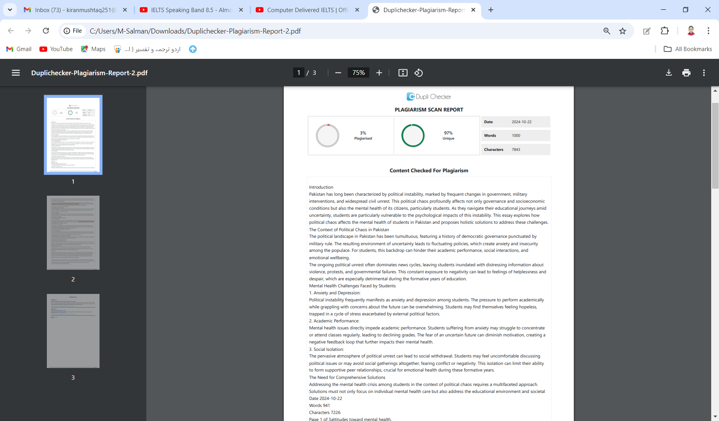**Plagiarism Report**